Pair Programming 2 Turn In

Name: _____Matthew Krahel _________ Username: _______C1010B11_________

Partner name: _______Blake Hodges___________ Partner username: ____C1010B06________

_X_ I certify that my partner did work with me on these pair programming activities.

SCORE: ____________ (to be filled in by instructor)

2a (1 point)

**/*File: pp2a.cpp**

**\* Author: Matthew Krahel and Blake Hodges**

**\* This program uses a variable, x, that has been declared and**

**\* initialized and uses output statements that print the output requested.**

**\*/**

**// Identifying the libraries and namespaces used in this program**

**#include <iostream>**

**using namespace std;**

**// Begin Main Function**

**int main()**

**{**

**// Declare the variable and the initialized amount**

**double x = 42.1298;**

**// Running output for requested paragraph with specific output format**

**cout << "The answer to the question of \n";**

**cout << "Life, the Universe, and Everything is ";**

**//Set the variable to display certain number of decimals**

**cout.setf(ios::fixed);**

**cout.precision(0); //To display no digits after the decimal**

**cout << x << ", not ";**

**cout.setf(ios::showpoint); //To display decimal**

**cout.precision(1); //To display one decimal place**

**cout << x;**

**cout << "\n \t and not $";**

**cout.precision(2); //To display two decimal places**

**cout << x << "\n";**

**return( 0 );**

**}**

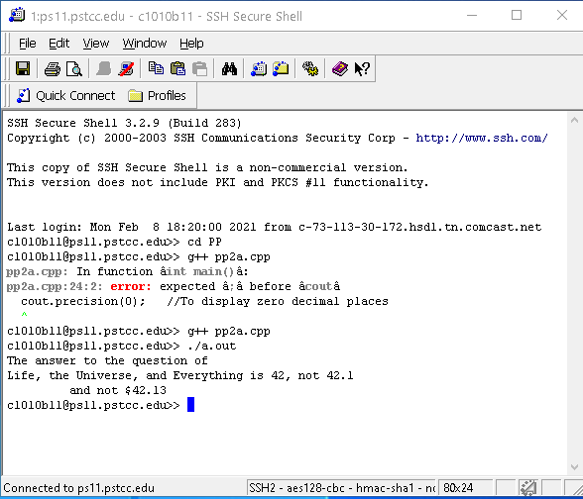

2b (2 points)

int i = 3, j = 10;

double x = 9.9, y = -0.6;

|  |  |  |
| --- | --- | --- |
| _0_ i / j | _3_ i % j | _3_ j / i |
| _1_ j % i | _2.99_ x * i / j | _0_ x * ( i / j) |
| _-13.5_ x / y + i | _9.9_ j + y / x | _-.33_ static_cast<double> (i) / j + y |

**/*File: pp2b.cpp**

**\* Author: Matthew Krahel and Blake Hodges**

**\* This program evaluates multiple expressions utilizing multiple variables**

**\*/**

**// Identifying the libraries and namespaces used in this program**

**#include <iostream>**

**using namespace std;**

**// Begin Main Function**

**int main()**

**{**

**// Declare the variables and the initialized amounts**

**int i = 3;**

**int j = 10;**

**double x = 9.9;**

**double y = -0.6;**

**// Running output for requested formulas**

**//First formula requested**

**cout << "i/j is " << (i / j) << "\n";**

**//Second formula requested**

**cout << "i%j is " << (i % j) << "\n";**

**//Third formula requested**

**cout << "j/i is " << (j / i) << "\n";**

**//Fourth formula requested**

**cout << "j%i is " << (j % i) << "\n";**

**//Set up to display decimals for the following equations**

**cout.setf(ios::fixed);**

**cout.setf(ios::showpoint);**

**//Fifth formula requested**

**cout.precision(2); //To display two decimal places**

**cout << "x*i/j is " << (x * i / j) << "\n";**

**//Sixth formula requested**

**cout.precision(2); //To display two decimal places**

**cout << "x*(i/j) is " << (x * (i / j)) << "\n";**

**//Seventh formula requested**

**cout.precision(1); //To display one decimal place**

**cout << "x/y+i is " << (x / y + i) << "\n";**

**//Eighth formula requested**

**cout.precision(5); //To display five decimal places**

**cout << "j+y/x is " << (j + y / x) << "\n";**

**//Ninth formula requested**

**cout.precision(2); //To display two decimal places**

**cout << "static_cast<double>(i)/j+y is " << (static_cast<double>(i) / j + y) << "\n";**

**return( 0 );**

**}**

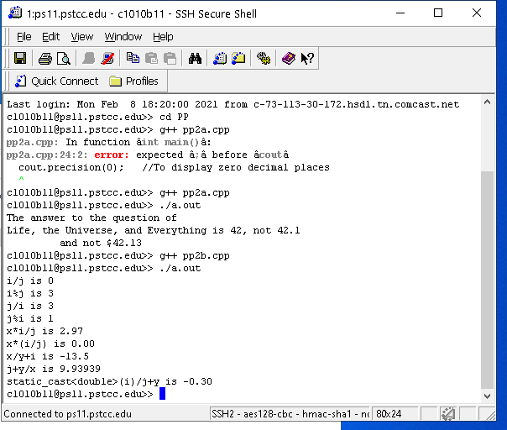

**Some of my answers were the same, some were not.**

**I had j + y/x wrong due to incorrect arithmic.**

**I did not have the static cast doing the double which gave me a wrong calculation when I estimated it.**

2c (3points)

**/*File: pp2c.cpp**

**\* Author: Matthew Krahel and Blake Hodges**

**\* This program takes the users inputted age and outputs whether they**

**\* are old enough for specific actions such as social security, voting, drinking...**

**\*/**

**// Identifying the libraries and namespaces used in this program**

**#include <iostream>**

**using namespace std;**

**// Begin Main Function**

**int main()**

**{**

**// Declare the variable**

**int age = 0;**

**// Request age input from user**

**cout << "Please type your age and hit enter:";**

**cin >> age; //Applying the users age to the variable for their age**

**cout << "Enter your age:" << age << "\n"; //Repeat Age to User**

**// Compare user age to age limits for specific actions**

**//(social security, renting a car, drinking alcohol) to give them**

**// the most recent milestone**

**if ( age >= 65 ) {**

**cout << "You can collect social security";**

**}**

**else if ( age >= 25 ) {**

**cout << "You can rent a car";**

**}**

**else if ( age >= 21 ) {**

**cout << "You can drink";**

**}**

**else if ( age >= 18 ) {**

**cout << "You can vote";**

**}**

**else {**

**cout << "";**

**}**

**cout << "\n\n"; //Make it a clean look by putting next some extra**

**//lines between each run of the program**

**return( 0 );**

**}**

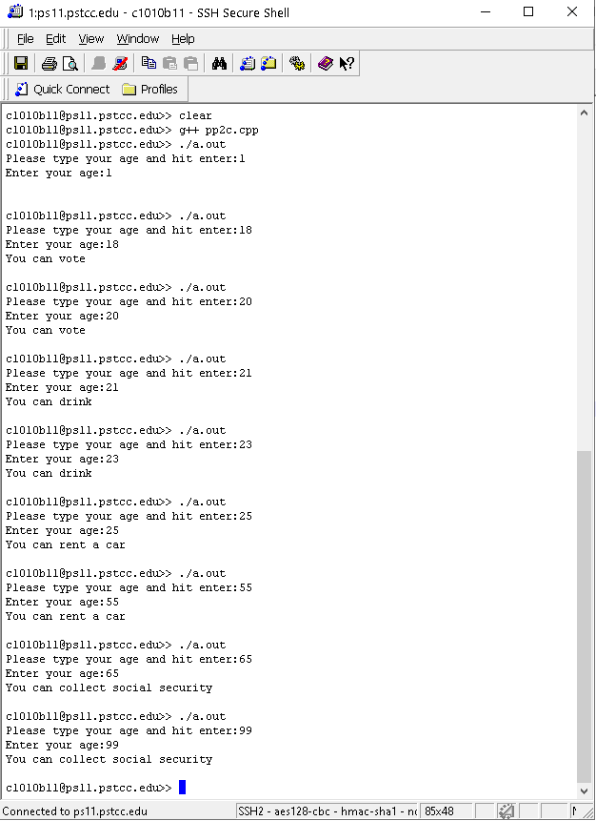

2d (2 points)

**/*File: pp2d.cpp**

**\* Author: Matthew Krahel and Blake Hodges**

**\* This program takes the users inputted grade as a number and**

**\* outputs their letter grade**

**\*/**

**// Identifying the libraries and namespaces used in this program**

**#include <iostream>**

**using namespace std;**

**// Begin Main Function**

**int main()**

**{**

**// Declare the variable**

**double scoreGrade = 0;**

**char letterGrade = 'A';**

**// Request score input from user**

**cout << "Please type your grade and hit enter:";**

**//Apply the users inputted score grade to the variable for their scoreGrade**

**cin >> scoreGrade;**

**//Repeat score grade to User**

**cout << "Enter grade:" << scoreGrade << "\n";**

**// Compare user scoreGrade to apply it to the grading scale and**

**//apply letter character to the letterGrade variable**

**if ( scoreGrade >= 93 ) {**

**letterGrade = 'A';**

**}**

**else if ( scoreGrade >= 83 ) {**

**letterGrade = 'B';**

**}**

**else if ( scoreGrade >= 73 ) {**

**letterGrade = 'C';**

**}**

**else if ( scoreGrade >= 65 ) {**

**letterGrade = 'D';**

**}**

**else {**

**letterGrade = 'F';**

**}**

**// Output User's letter grade**

**cout << letterGrade << "\n\n";**

**return( 0 );**

**}**

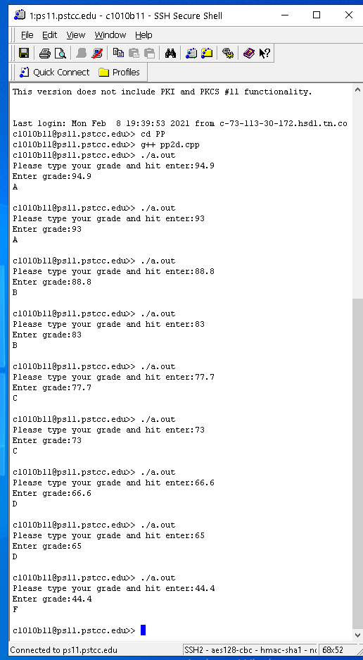

2e (2 points)

**/*File: pp2e.cpp**

**\* Author: Matthew Krahel and Blake Hodges**

**\* This program takes the users inputted marriage status and outputs a**

**\* message based on that status**

**\*/**

**// Identifying the libraries and namespaces used in this program**

**#include <iostream>**

**using namespace std;**

**// Begin Main Function**

**int main()**

**{**

**// Declare the variable**

**char marriageStatus;**

**// Request marriage status from user**

**cout << "Please type your marriage status (M for Married or S for Single) and hit enter:";**

**//Applying the users inputted Marriage Status to the variable**

**cin >> marriageStatus;**

**//Repeat marriage status to User**

**cout << "Enter status (M or S): " << marriageStatus << "\n";**

**// Compare user marriage status to the correct output response**

**switch ( marriageStatus ) {**

**case 'M': case 'm':**

**cout << "We hope for many years of happiness for you and your spouse!\n";**

**break;**

**case 'S': case 's':**

**cout << "We hope for all your dreams to come true!\n";**

**break;**

**default:**

**cout << "Invalid marital status " << marriageStatus << ".\n";**

**}**

**return( 0 );**

**}**

